

**IMP Methods of ApplicationContext**

**Lab49: Files required**



|  |  |  |  |
| --- | --- | --- | --- |
| **1.** | **Lab49.java** | **2.** | **Hai.java** |
|  |  |  |  |
| **3.** | **Hello.java** | **4.** | **JLCAppConfig.java** |
|  |  |  |  |



**1. Lab49.java**

**package com.coursecube.spring;**

**import org.springframework.context.ApplicationContext;**

**import org.springframework.context.annotation.AnnotationConfigApplicationContext; /\***

* **@Author : Srinivas Dande**
* **@Company : CourseCube**
* **@Website : www.coursecube.com**
* **\*/**

**public class Lab49 {**

**public static void main(String[] args) {**

**ApplicationContext ctx = new AnnotationConfigApplicationContext(JLCAppConfig.class);**

|  |  |  |  |  |
| --- | --- | --- | --- | --- |
| **System.out.println("---------** | **Now Spring Container is Ready-----** | | | **");** |
| **System.out.println("1. Get the bean with Bean Name--** | | | **");** |  |
| **Hello hello1 = (Hello) ctx.getBean("myhello");** | | |  |  |
| **hello1.show();** |  |  |  |  |
| **System.out.println("2. Get the bean with Bean Type--** | | | **");** |  |
| **Hello hello2 = ctx.getBean(Hello.class);** | |  |  |  |
| **hello2.show();** |  |  |  |  |
| **System.out.println("3. Get the bean with Bean Name and Bean Type--");** | | | | |
| **Hello hello3 = ctx.getBean("myhello", Hello.class);** | | |  |  |
| **hello3.show();** |  |  |  |  |
| **System.out.println("------------------------------------------------------** | |  |  | **");** |
| **System.out.println("4. " + ctx.getBeanDefinitionCount());** | | | |  |
| **System.out.println("5. List of Beans---------** | | **");** |  |  |
| **String bnames[] = ctx.getBeanDefinitionNames();** | | |  |  |
| **for (String bname : bnames) {** | |  |  |  |
| **System.out.println(bname);** | |  |  |  |
| **}** |  |  |  |  |
| **System.out.println("------------------------------------------------------** | |  |  | **");** |
| **System.out.println("6. " + ctx);** | |  |  |  |
| **System.out.println("7. " + ctx.getDisplayName());** | | |  |  |
| **System.out.println("8. " + ctx.getId());** | |  |  |  |
| **System.out.println("9. " + ctx.getStartupDate());** | | |  |  |
| **System.out.println("10. " + ctx.getType("myhello"));** | | |  |  |
|  |  |  |  |  |



**www.coursecube.com** **139** **Spring-5 Study Guide**

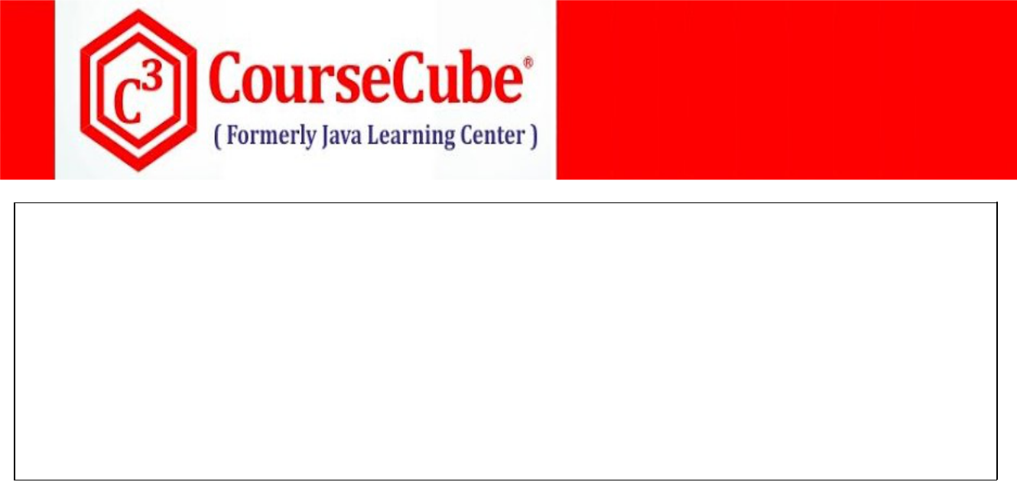

**System.out.println("11A. " + ctx.containsBean("myhello")); System.out.println("11B. " + ctx.containsBean("myhello1"));**

**System.out.println("12A. " + ctx.isSingleton("myhai")); System.out.println("12B. " + ctx.isSingleton("myhello"));**

**System.out.println("13A. " + ctx.isPrototype("myhai")); System.out.println("13B. " + ctx.isPrototype("myhello")); }**

**}**



**2. Hai.java**

**package com.coursecube.spring;**

**/\***

* **@Author : Srinivas Dande**
* **@Company : CourseCube**
* **@Website : www.coursecube.com**
* **\*/**

**public class Hai {**

**String str; //Dependency**

**public void setStr(String str) {**

**this.str = str;**

**}**

**public String toString() {**

**return str;**

**}**

**}**



**3. Hello.java**

**package com.coursecube.spring;**

**import org.springframework.beans.factory.annotation.Autowired; /\***

* **@Author : Srinivas Dande**
* **@Company : CourseCube**
* **@Website : www.coursecube.com**
* **\*/**

**public class Hello {**

**@Autowired**

**Hai hai;**

**public void show() {**

**System.out.println("Hello-show()");**

**System.out.println(hai);**

**}**

**}**



**www.coursecube.com** **140** **Spring-5 Study Guide**



1. **JLCAppConfig.java package com.coursecube.spring;**

**import org.springframework.context.annotation.Bean;**

**import org.springframework.context.annotation.Configuration; /\***

* **@Author : Srinivas Dande**
* **@Company : CourseCube**
* **@Website : www.coursecube.com**
* **\*/**

**@Configuration**

**public class JLCAppConfig {**

**@Bean(name = "myhai")**

**public Hai createHai() {**

**Hai hai = new Hai();**

**hai.setStr("I am Bean - Hai");**

**return hai;**

**}**

**@Bean(name = "myhello")**

**public Hello createHello() {**

**return new Hello();**

**}**

**}**



**Interview Questions – Part 2**

**Q161) What is the Advantage of Externalizing Bean Properties?**

**Ans:**

**Q162) What is the Bean to Configure to access Externalized Bean Properties?**

**Ans:**

**Q163) How to access the Externalized Bean Properties from Property Files?**

**Ans:**

**Q164) What is the use @Value Annotation?**

**Ans:**

**Q165) How the Properties from Environment Object?**

**Ans:**



**www.coursecube.com** **141** **Spring-5 Study Guide**



**Q166) How to Implement Internationalization(I18N)?**

**Ans:**

**Q167) What are the Naming Conventions to follow when you write Multiple Message Bundles?**

**Ans:**

**Q168) What is the Bean to Configure to access Messages from Message Bundles?**

**Ans:**

**Q169) How to access Messages from Message Bundles?**

**Ans:**

**Q170) What is the use of MessageSource?**

**Ans:**

**Q171) What is the use of PropertyEditors?**

**Ans:**

**Q172) What is the Super for Custom PropertyEditor class?**

**Ans:**

**Q173) What is the method to Override in Custom PropertyEditor class?**

**Ans:**

**Q174) What are the Setps to write Custom PropertyEditors?**

**Ans:**

**Q175) How to Register Custom PropertyEditor with Container?**

**Ans:**

**Q176) What are the standard events provided by the Spring Container?**

**Ans:**

**Q177) When exactly ContextStartedEvent will be published by the Spring Container?**

**Ans:**

**Q178) When exactly ContextRefreshedEvent will be published by the Spring Container?**

**Ans:**

**Q179) When exactly ContextStoppedEvent will be published by the Spring Container?**

**Ans:**

**Q180) When exactly ContextClosedEvent will be published by the Spring Container?**

**Ans:**



**www.coursecube.com** **142** **Spring-5 Study Guide**



**Q181) Can I refresh() method explicitly on ConfigurableApplicationContext?**

**Ans:**

**Q182) What are the Ways Available to Write the Listeners in Spring?**

**Ans:**

**Q183) What are the Steps to Write the Listeners with ApplicationListener interface?**

**Ans:**

**Q184) What are the Steps to Write the Listeners with @EventListener annotation?**

**Ans:**

**Q185) How to Register the Listeners with Spring Container?**

**Ans:**

**Q186) Can I write the One Listener to Handle Multiple Events?**

**Ans:**

**Q187) Can I write the Multile Listeners to Handle One Event?**

**Ans:**

**Q188) Can I write the Different Listeners to Handle Dedicated Events?**

**Ans:**

**Q189) What are the Ways Available to Write the Application Events or Custom Events?**

**Ans:**

**Q190) What are the Steps to Write the Custom Events with ApplicationEvent class?**

**Ans:**

**Q191) Can I write the Custom Events without ApplicationEvent class?**

**Ans:**

**Q192) What are the Steps to Write the Custom Events without ApplicationEvent class?**

**Ans:**

**Q193) How to publish Application Events?**

**Ans:**

**Q194) What is the Use of ApplicationEventPublisher?**

**Ans:**

**Q195) How Can I access the Requied Bean Object from Spring container?**

**Ans:**

**Q196) How Can I get the List of Bean Names running in the Spring container?**

**Ans:**



**www.coursecube.com** **143** **Spring-5 Study Guide**



**Q197) How Can I Total Number of Beans running in the Spring container?**

**Ans:**

**Q198) How Can I check whether Bean with the given Bean Name is running in the Spring container?**

**Ans:**

**Q199) How Can I check type of Bean with the given Bean Name?**

**Ans:**

**Q200) How Can I check whether Bean is Singleton?**

**Ans:**

**Q201) How Can I check whether Bean is Prototype?**

**Ans:**

**Q202) What are the stereotype annotations?**

**Ans:**

**@Component**

**@Controller**

**@Service**

**@Repository**

**Q203) What is the use of stereotype annotations?**

**Ans:**

**Q204) When Can I use @Controller annotation?**

**Ans:**

**Q205) When Can I use @Service annotation?**

**Ans:**

**Q206) When Can I use @Repository annotation?**

**Ans:**

**Q207) When Can I use @Component annotation?**

**Ans:**

**Q208) When Can I use @ComponentScan annotation?**

**Ans:**

**Q209) What is the Need for Injecting ApplicationContext into the Bean?**

**Ans:**

**Q210) What are the Annotations Used in IOC so far?**

**Ans:**



**www.coursecube.com** **144** **Spring-5 Study Guide**